**Satō Haruo 佐藤 春夫 (1892–1964)**

Satoko Kakihara

SUMMARY

Satō Haruo was a modern Japanese writer and poet active from the late-Meiji to the mid-Shōwa era, roughly from the 1910s until his death in 1964. He worked on a wide range of genres, from the novel, poetry, and drama to literary criticism, essay, and biography. He dealt with such issues as love, romance, melancholy, and weariness, being affiliated with literary movements of intellectualism and aestheticism. While he had been concerned with anarchist ideologies at the beginning of his career, he turned more to theories of traditional Japanese beauty toward the end of his career.

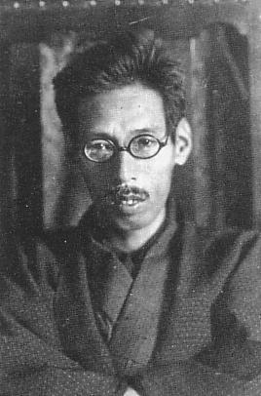

Satō Haruo

<http://ja.wikipedia.org/wiki/%E4%BD%90%E8%97%A4%E6%98%A5%E5%A4%AB#/media/File:Haruo_Sato.JPG>

MAIN ENTRY

Satō Haruo was born on 9 April 1892 (Meiji 25) as the first son of Satō Toyotarō, a physician, and his wife, Masayo, in Wakayama Prefecture. From a young age Satō enjoyed reading and writing poetry, and in 1908 his poem ‘Kaze’ [‘Wind’] was selected for publication in the monthly poetry journal *Myōjō*, run by Yosano Tekkan. Through this occasion Satō met other key cultural figures of the time, including Ikuta Chōkō, Ishii Hakutei, and Ishikawa Takuboku. In 1910 Satō relocated to Tokyo to become a student of Ikuta, and he also joined Tekkan and Yosano Akiko’s poetry association, Shinshisha, which aimed to revolutionize traditional Japanese poetry and eventually became a powerful force of romanticism in Japanese poetry. He also joined the preparatory course at Keio University, though he later left the university in 1913.

In 1914 he published the short story ‘Supein inu no ie’ [‘The House of a Spanish Dog’], which was subtitled ‘A short story for those who like to enter into a dream-like state.’ The story involves the narrator taking a walk with his dog through the woods, traveling deeper into a realm of fantasy that involves anthropomorphism and loss of a sense of self. This was followed by the publication of *Den’en no yūutsu* [*Melancholy in the Country*] (1919), for which he gained recognition as a novelist. *Melancholy in the Country*, together with *Tokai no yūutsu* [*Melancholy in the City*] (1922), told the story of a writer who struggled to write amidst different environments of city and country, caught within the tiring dynamic among his wife, his dogs, and himself. The two works were both introspective works about the self-conscious difficulties of a writer.

Along with the publication of his poetry collection *Junjō shishū* [*Sentimental Poetry*] (1921) and his literary criticism in *Taikutsu dokuhon* [*Boredom Reader*](1926), Satō established himself as a representative writer of the Taishō era. In addition, from June through October of 1920, Satō traveled to Fujian Province in China and Taiwan, journeying through the Japanese colony and meeting Mori Ushinosuke, an anthropologist who studied aboriginal communities in Taiwan. This trip enabled him to consider the juxtaposition of ethnography and literature. In 1927 he also traveled through various parts of Japan as part of a lecture tour for the publisher Kaizōsha, and he traveled to China in July of that year as well. He continued to write during the Shōwa era, publishing such works as *Akiko mandara* [*Akiko Mandala*] (1954), a novelization of Yosano Akiko’s biography.

Satō passed away on 6 May 1964 (Shōwa 39) due to a heart attack. After his death, Satō’s Tokyo home was relocated and reconstructed in Shingū City of Wakayama Prefecture, and it was reopened by the city as Satō Haruo Memorial Museum. The house is said to mix both Japanese culture and Western modernism. It was designed by Satō himself, and those who knew him describe it as exuding qualities of romanticism and modernism that were unique to Satō. Still others describe it as exotic, even Märchen-like—an appropriate legacy for a writer such as Satō.

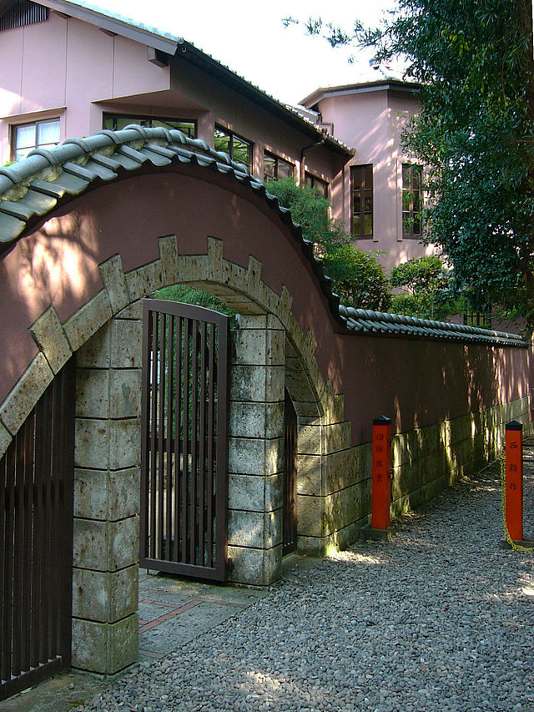

Shingū City Satō Haruo Memorial Museum

<http://ja.wikipedia.org/wiki/%E4%BD%90%E8%97%A4%E6%98%A5%E5%A4%AB%E8%A8%98%E5%BF%B5%E9%A4%A8#/media/File:Sato_Haruo_Memorial_Museum03s1800.jpg>

**List of Works**

Collected works

*Satō Haruo zenshū* (3 vols, 1931–32), Tokyo: Kaizōsha.

*Teibon Satō Haruo Zenshū* (38 vols, 1998–2001), Kyoto: Rinsen shoten.

Selected works

*Jisen Satō Haruo zenshū* (10 vols, 1956–58), Tokyo: Kawade shobō.

*Satō Haruo zenshū* (12 vols, 1966–70), Tokyo: Kōdansha.

Short story

‘Supein inu no ie’[‘The House of a Spanish Dog’] (1914)

Novels

*Den’en no yūutsu* [*Melancholy in the Country*] (1919)

*Tokai no yūutsu* [*Melancholy in the City*] (1922)

*Akiko mandara* [*Akiko Mandala*] (1954)

Poetry

‘Kaze’ [‘Wind’] (1908)

*Junjō shishū* [*Sentimental Poetry*] (1921)

*Ri Taihaku* [*Li Bai*] (1924)

Literary criticism

*Taikutsu dokuhon* [*Boredom Reader*](1926),

English translations

Satō Haruo. (1996) *Beautiful Town: Stories and Essays*, tr. Francis B. Tenny, Honolulu: University of Hawai‘i Press.

Satō Haruo. (2013) ‘A Record of Nonchalant’, in *Three-Dimensional Reading: Stories of Time and Space in Japanese Modernist Fiction, 1911–1932*, ed. Angela Yiu, Honolulu: University of Hawai‘i Press, 211–239.

Satō Haruo. (1993) *The Sick Rose: A Pastoral Elegy*, tr. Francis B. Tenny, Honolulu: University of Hawai‘i Press.

**References and further reading**

Etō, Jun. (1964) ‘An Undercurrent in Modern Japanese Literature’, *The Journal of Asian Studies* 23 (03): 433–445.

Kleeman, Faye Yuan. (2006) ‘Modernity, history, and the uncanny: Colonial encounter and the epistemological gap’, in *Representing the Other in Modern Japanese Literature: A Critical Approach*, eds. Rachael Hutchinson and Mark Williams, New York: Routledge, 271–291.

Suzuki, Tomi. (1996) *Narrating the Self: Fictions of Japanese Modernity*, Stanford: Stanford University Press.